Date:22/10/24
A.Y 2024-25(Odd Sem)
Report on PSR Activity: Super AI Community Stakeholder Connect

Objective:
The aim of these activities is to build students’ knowledge in Artificial Intelligence (AI) and Machine Learning (ML) by exposing them to real-world applications in diverse sectors, such as healthcare, finance, and gaming. Through peer learning, expert sessions, and practical workshops, students will enhance their technical and problem-solving skills. These initiatives also focus on career readiness by providing guidance on placements, entrepreneurship, and participation in national-level hackathons, helping students prepare for success in the fast-evolving AI/ML industry.
Following activities are done during Academic Year 2024-25 Odd Semester:

Activity 1: Introduction to AI & ML Sectors and Peer Learning Session on Kaggle Platform.

Date: 13 July 2024
Time: 3:00 PM - 6:00 PM
Speaker: Miss Yesha Raval, BT student, TCET and Mr. Ishaan Gupta, BT student, TCET

Participants: ST, TT and BT Students

Objectives:

- To introduce students to the diverse applications of AI & ML across various sectors.
- Equip students with an understanding of how AI & ML technologies are transforming industries.
- Provide hands-on exposure to real-world AI/ML challenges using Kaggle.
- Encourage collaboration and problem-solving through machine learning competitions.
- Inspire students to explore AI/ML career paths and participate actively in related projects.

Description:
This session was divided into two parts. The first part introduced students to the significant impact of AI & ML across various sectors, featuring expert speakers who shared real-world use cases from industries such as healthcare, finance, and gaming. Interactive discussions and a Q&A session addressed students' queries about AI career paths and industry trends.
The second part focused on peer learning through Kaggle, an online platform for data science competitions. Students learned how to select datasets, build models, and submit results. The hands-
on component encouraged collaboration on beginner-level Kaggle challenges, fostering problem- solving and teamwork while highlighting the importance of such platforms for developing technical skills in real-world AI applications.

Activity Photo:
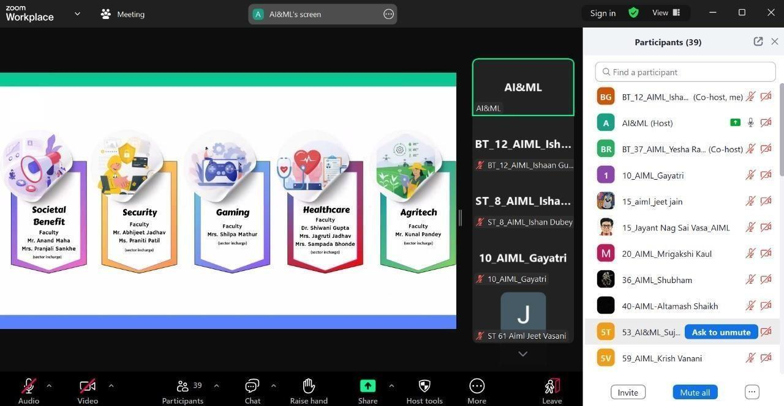

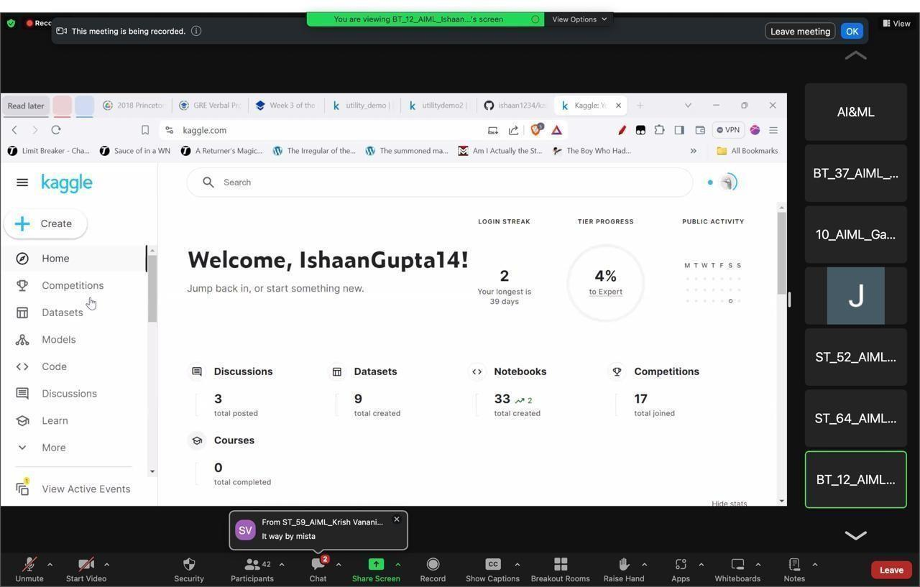

Participation Analysis:
- Introduction to AI & ML Sectors

Sr. No. | Class | No. of Students

1 | ST | 48
Total: |  | 48

- Session on Kaggle Platform

Sr. No. | Class | No. of Students
1 | ST | 29
2 | TT | 26
3 | BT | 12
Total: |  | 67

Feedback Analysis:

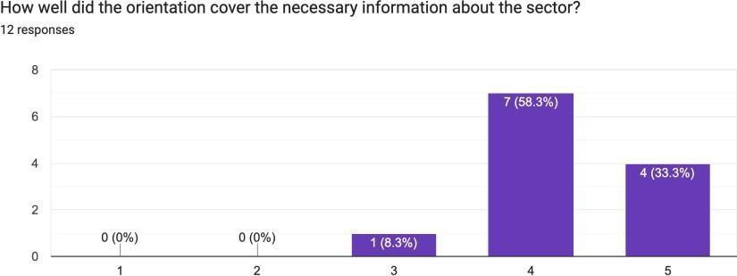

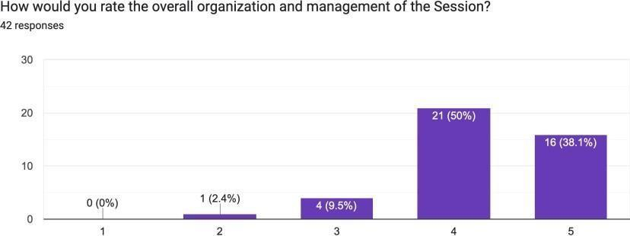

Outcome:
  - Students were introduced to both theoretical and practical aspects of AI & ML. They gained a better understanding of AI’s impact across multiple sectors and became familiar with Kaggle as a tool for improving their data science and ML skills. Several students expressed interest in pursuing AI/ML certifications and participating in Kaggle competitions. Collaborative efforts in the session led to the formation of study groups focused on upcoming.
competitions, and many participants began planning their next steps in AI/ML career paths.

PO Attained: PO2, PO9, PO10

Activity 2: Aptitude Test - Skill Development.
Date: 20 July 2024
Time: 3:00 PM to 5:00 PM

Participants: ST, TT and BT Students

Objectives:
  - To simulate a competitive exam environment and provide feedback.
  - To identify areas of improvement in quantitative, verbal, and logical reasoning.
  - To prepare students for upcoming technical and competitive assessments.

Description:
The aptitude test aimed at assessing students' problem-solving and reasoning skills, focusing on analytical questions that simulate competitive exams. The test covered areas such as logical reasoning, quantitative aptitude, and verbal ability. It was structured with time constraints to prepare students for real-world exam scenarios. After the test, students were given feedback and strategies for improving their performance in future assessments.

Activity Photo:

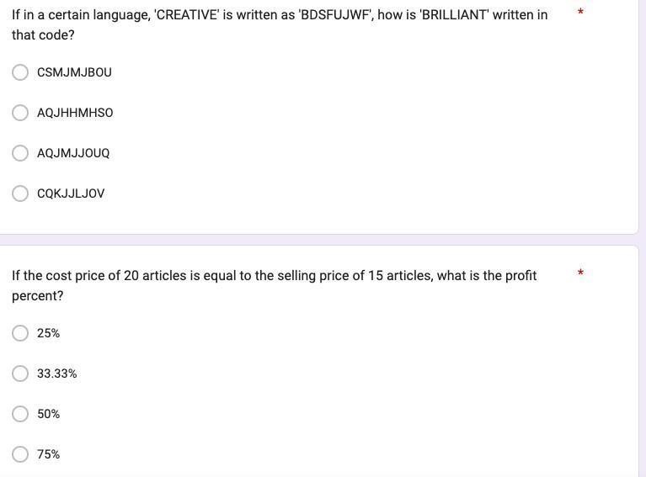

Participation Analysis:

Sr. No. | Class | No. of Students
1 | ST | 33
2 | TT | 26
3 | BT | 05
Total: |  | 64

Feedback Analysis:

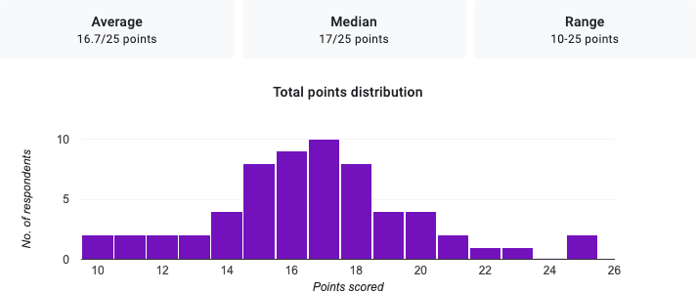

Outcome:
The test helped students identify areas for improvement in their aptitude and logical reasoning skills. Feedback was provided, highlighting common mistakes and strategies for better performance. The test also fostered a spirit of healthy competition among peers, motivating students to enhance their problem-solving abilities.

PO Attained: PO1, PO3, PO5, PO6

Activity 3: Visit to AR/VR Lab - Gaming Sector.
Date: 2 August 2024
Time: 1:00 PM to 3:00 PM

Participants: ST and TT Students

Objectives:

The session aimed to:
  - To provide students with hands-on experience in AR/VR technologies used in the gaming sector.
  - To demonstrate how AI enhances immersive gaming experiences.
  - To encourage students to explore AI applications in AR/VR technologies beyond gaming.
  - To inspire students to consider careers in AI-driven gaming technology.

Description:
This lab visit focused on how Augmented Reality (AR) and Virtual Reality (VR) are used in the gaming sector. Students were introduced to VR devices and explored real-time rendering techniques that enhance gaming experiences. The session featured a hands-on demonstration of a game built with AR/VR elements, where students could observe the role of AI in simulating dynamic environments. The visit also provided insights into how AR/VR technologies can be applied beyond gaming, in sectors such as education and healthcare.

Activity Photo:

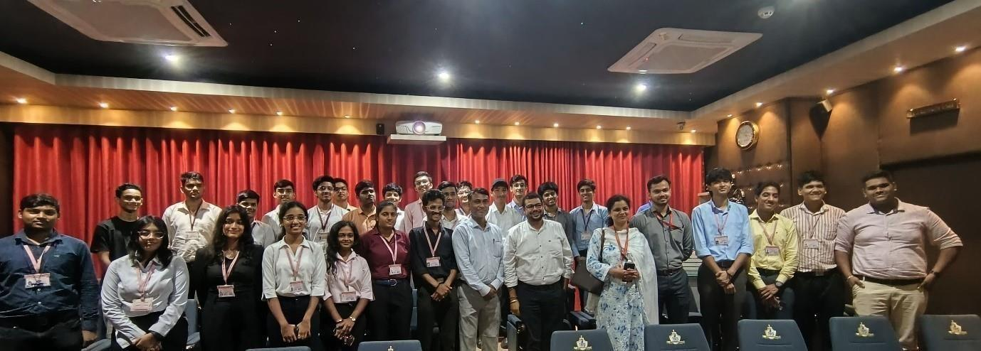
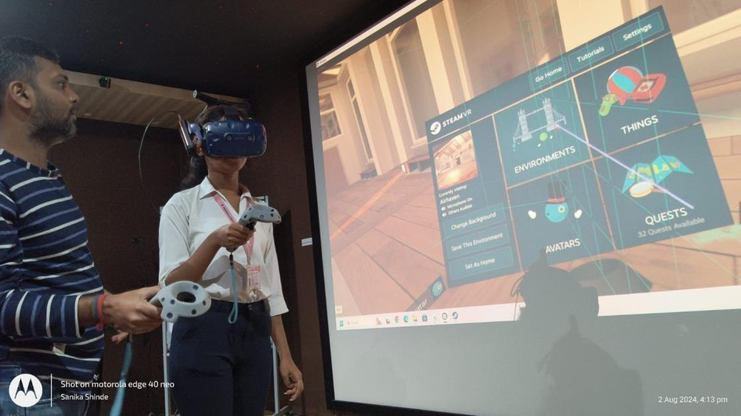

Participation Analysis:

Sr. No. | Class | No. of Students
1 | ST | 7
2 | TT | 19
Total: |  | 26

Feedback Analysis:

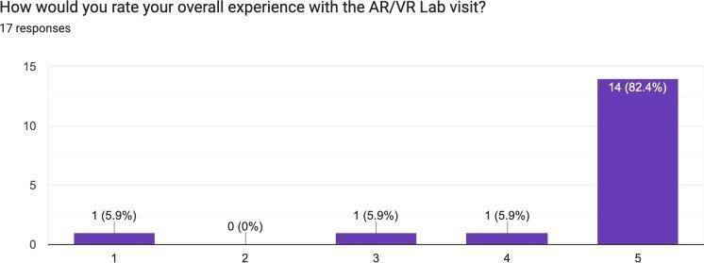

Outcome:
The visit offered students practical exposure to immersive technologies used in game development and simulation. It sparked interest among participants to explore AR/VR-based projects, and many students expressed their eagerness to integrate AI into gaming environments. The lab visits also helped students grasp the potential of AR/VR in industries beyond gaming.

PO Attained:PO1, PO2, PO3, PO5

Activity 4: Alumni Session on Placement Guidance
Date: 3 August 2024
Time: 10:00 AM to 12:00 PM
Speakers-Payal Chandak, SDE, Oracle and Tanmay Singhania, SDE, Oracle
Participants: ST, TT, BT and Students.

Objectives:

  - To offer students insights and strategies for securing placements in the AI/ML industry.
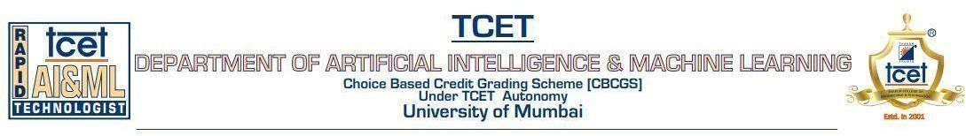
  - To guide students on resume building, interview preparation, and networking.
  - To encourage students to leverage internships and projects for career growth.
  - To equip students with tools to enhance their professional profiles, including LinkedIn.

Description:
The alumni session provided a roadmap for students aiming to secure placements in the AI and ML industry. Alumni shared personal experiences on how to navigate the job market, build a compelling resume, and prepare for technical interviews. The session also covered networking strategies, emphasizing the importance of building a strong professional presence on platforms like LinkedIn.

Activity Photo:
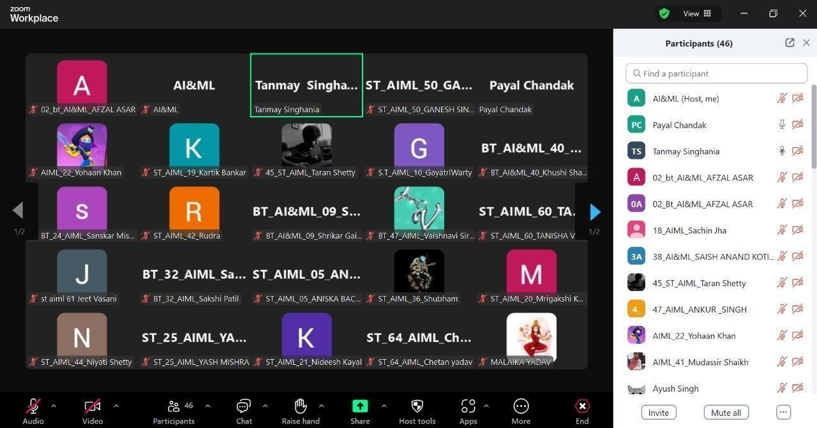

Participation Analysis:

Sr. No. | Class | No. of Students
1 | ST | 30
2 | BT | 18
Total: |  | 48

Feedback Analysis:

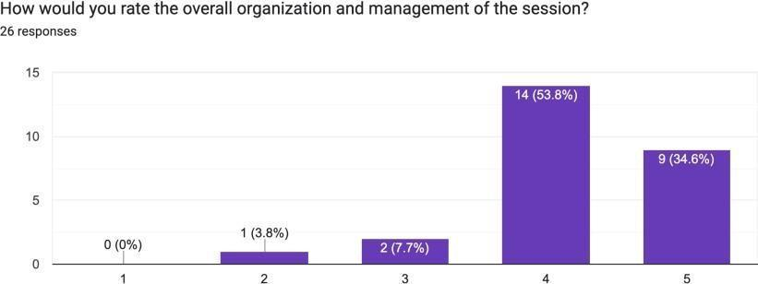

Outcome:
The session offered valuable advice on preparing for placements, including resume building, interview techniques, and networking. Students left with a clear roadmap to secure AI & ML positions and were encouraged to apply the strategies discussed. Several students have started applying these techniques to improve their job prospects and personal branding.
PO Attained:PO1, PO2, PO4, PO9

Activity 5: Alumni Session on Guidance for National Level Hackathons.
Date – 11 August 2024 Time – 6:00PM to 8:00PM
Speaker- Atharva Tendulkar, Product Manager, NxtWave and Prashant Kapri, Full Stack, Barclays
Participants: ST, TT and BT Students

Objectives:

The session aimed to:

  - To motivate students to participate in national-level hackathons.
  - To provide guidance on effective problem-solving, teamwork, and time management.
  - To showcase tools and platforms commonly used in hackathons.
  - To inspire students to use hackathons as a learning opportunity and career accelerator.

Description:
This session featured alumni who have successfully participated in national-level hackathons. They provided students with tips on how to approach problem-solving under time constraints, form effective teams, and work collaboratively. Participants were introduced to tools and platforms.
frequently used in hackathons.

Activity Photo:

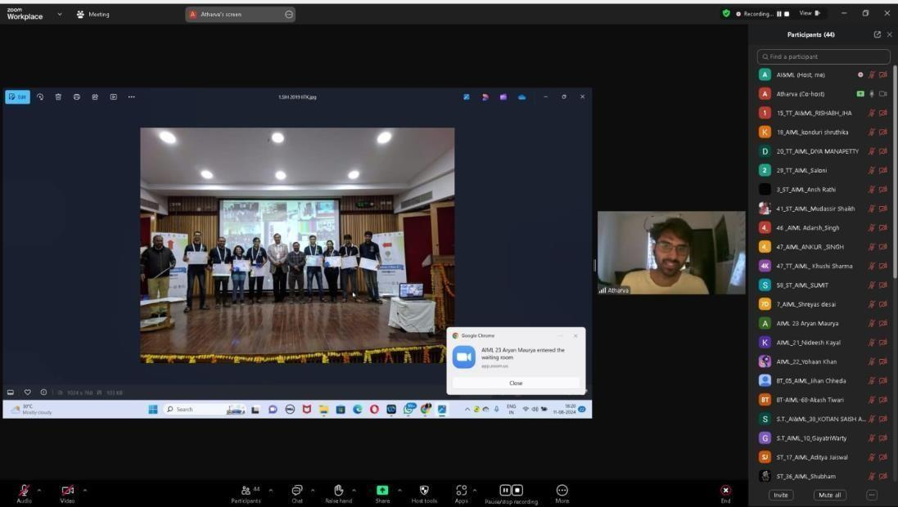

Participation Analysis:

Sr. No. | Class | No. of Students
1 | ST | 30
2 | TT | 18
3 | BT | 5
Total: |  | 53

Feedback Analysis:

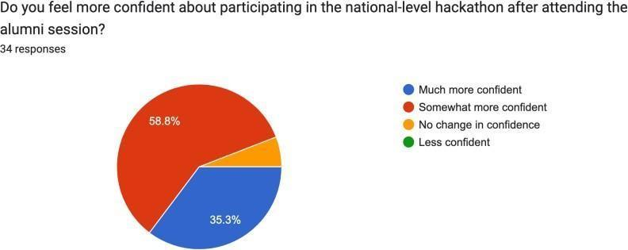

Outcome:

Students gained a deeper understanding of how to excel in hackathons and sharpen their problem- solving abilities. Several participants expressed interest in forming hackathon teams and have already begun preparing for upcoming national events. The session also reinforced the importance of team dynamics and innovative thinking during competitions.

PO Attained:PO1, PO2, PO4, PO9

Activity 6: Aptitude Test-1 & 2 - Skill Development

Date: 8 August 2024
Time: 3:00 PM - 5:00 PM

Participants: ST, TT and BT Student

Objective:

The workshop aimed to:

- To assess students’ progress in analytical thinking and critical thinking skills.
- To provide personalized feedback based on performance metrics.
- To simulate real-world exam scenarios with complex problem-solving questions.
- To emphasize continuous practice and improvement.

Description:

This round of aptitude tests was designed to measure students' progress in analytical thinking and reasoning skills. The test featured complex problem-solving questions that required students to apply their knowledge of math, logic, and critical thinking. The assessment was followed by a detailed analysis of performance metrics, with personalized feedback provided to each student.

Activity Photo:
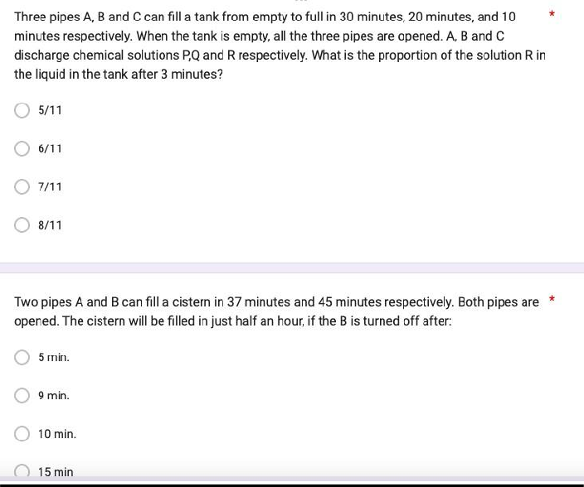

Participation Analysis:

- Test-1

Sr. No. | Class | No. of Students
1 | ST | 29
2 | TT | 16
Total: |  | 45

- Test-2

Sr. No. | Class | No. of Students
1 | ST | 8
2 | TT | 18
Total: |  | 26

Feedback Analysis:

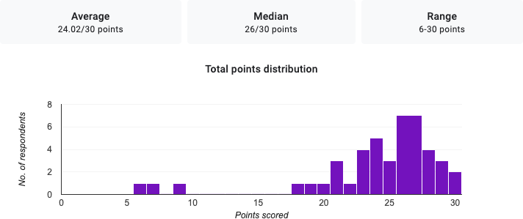

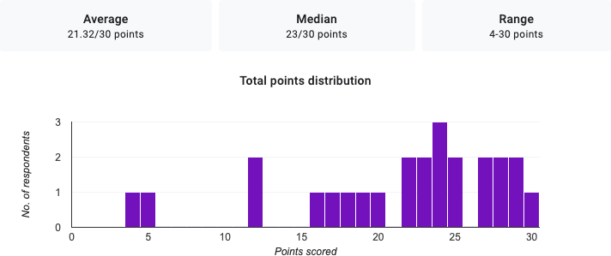

Outcomes:

Students were able to evaluate their progress and work on areas needing improvement. Feedback was given to guide students on specific problem-solving strategies. The test also helped students understand how to approach questions under timed conditions, which is critical for competitive exam success.

Activity 7: Peer Session on Ethics in AI.
Date: 20 September 2024 Time: 5:30PM to 6:30 PM
Speakers – Mr. Akshay Vennikkal, BT student, TCET
Participants: ST, TT and BT Students

Objectives:
- To explore the ethical implications of AI in various sectors.
- To raise awareness about bias, privacy, and societal impacts of AI.
- To introduce ethical frameworks such as “AI for Good” and responsible AI practices.

Description:
This session explored the ethical implications of AI in various sectors, including healthcare, finance, and law enforcement. Students discussed the potential risks of bias in AI models, privacy concerns, and the societal impact of AI-driven automation. The session also touched on ethical frameworks like AI for Good, encouraging students to consider the long-term consequences of AI deployment.

Activity Photo:

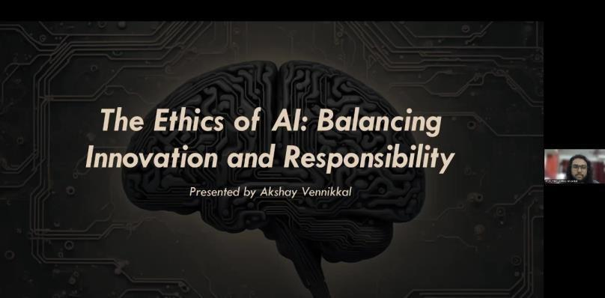

Participation Analysis:

Sr. No. | Class | No. of Students
1 | ST | 32
2 | TT | 26
3 | BT | 10
Total: |  | 68

Feedback Analysis:

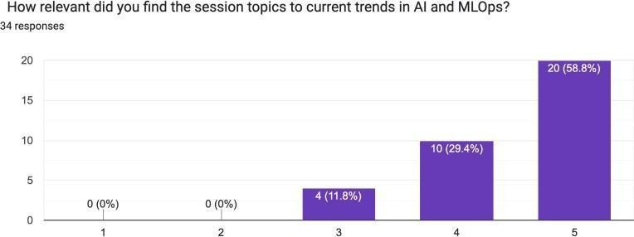
Outcome:
The session sparked discussions on the ethical use of AI and its implications for society. Students showed a deep interest in understanding how ethical frameworks could be integrated into AI development.
PO Attained: PO1, PO2, PO8, PO9

Activity 8: Peer Learning Session on MLOps. Date – 20 September 2024
Time – 12.00 to 6.30PM
Speaker: Mr. Ankit Mishra, BT student, TCET
Participants: ST, TT, BT Students

Objectives:

- To introduce students to MLOps, a methodology that integrates ML with software engineering practices.
- To familiarize students with tools like Kubernetes and Docker for ML model deployment.
- To teach best practices for monitoring, troubleshooting, and maintaining ML models.
- To provide hands-on experience with deploying ML models using MLOps frameworks

Description:
This peer-led session introduced MLOps as a methodology that integrates machine learning with software engineering practices. Students were introduced to tools like Kubernetes and Docker, which are commonly used for deploying and managing machine learning models. The session also covered best practices for monitoring ML models, troubleshooting errors in production, and maintaining model accuracy.

Participation Analysis:

Sr. No. | Class | No. of Students
1 | ST | 33
2 | TT | 30
3 | BT | 13

Total: | 76

Activity Photo:

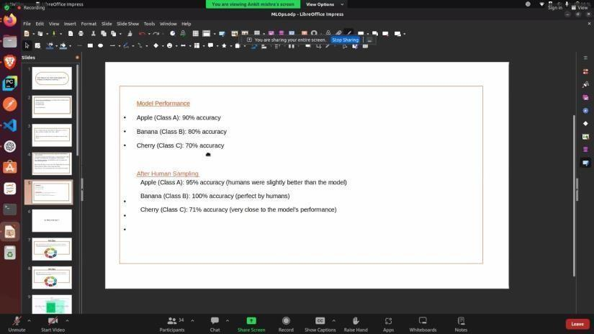

Feedback Analysis:



Outcome:

  - Students gained insights into how MLOps is used to streamline and manage AI/ML models in production environments. They were introduced to tools and frameworks that simplify ML model deployment. Participants are now more confident in managing AI projects from development to production.

PO Attained:PO1, PO2, PO3, PO5

Activity 9: Expert Session on Startups.

Date – 27 September 2024

Time: 4.30 PM to 5.30 PM
Speaker: Mr. Dnyaneshwar Bhabad, Assistant Manager, Deloitte Industry Expert

Participants: ST, TT and BT Students

Objective:

The session aimed to:

  - To inspire students to explore entrepreneurship in AI and ML.
  - To share insights on building and validating startup ideas.
  - To provide practical strategies for securing funding and navigating the tech startup space.
  - To equip students with knowledge about the challenges faced by AI startups and how to overcome them.

Description:

The expert session was designed to inspire students to explore entrepreneurship in AI and ML. A successful startup founder shared insights into how to develop a startup idea, validate it, and bring it to market. The session covered the importance of building a solid business plan, securing funding, and finding a niche in the competitive AI startup space.

Participation Analysis:

Sr. No. | Class | No. of Students
1 | ST | 38
2 | TT | 30
3 | BT | 18
Total: |  | 86

Activity Photo:
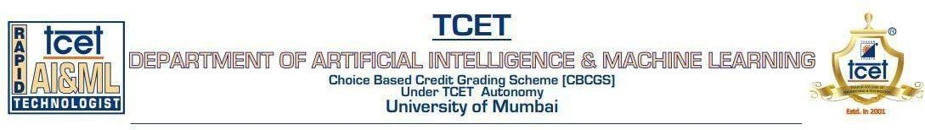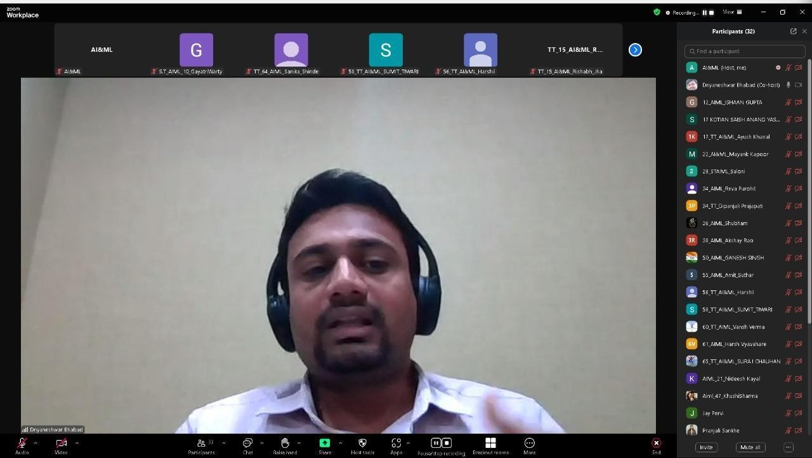

Feedback Analysis:

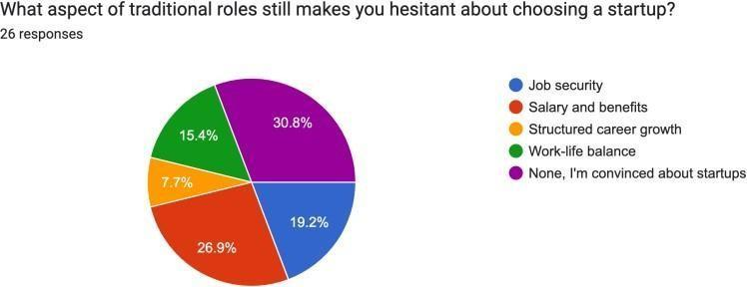

Outcome:

  - The session motivated students to explore entrepreneurship opportunities within the AI & ML space. Several students expressed interest in launching their own startups or joining early-stage tech companies.

PO Attained:PO1, PO2, PO4, PO5

Activity 10: Application of AI in Agriculture.
Date: 28 September 2024
Time: 9:30 AM to 10:30 AM
Speaker: Dr. Vaishali Nirgude, Assistant Professor in Computer Engineering at TCET.

Participants: ST and TT students

Objectives:
  - To discuss how AI is transforming agriculture through innovative technologies.
  - To introduce students to AI applications like precision farming and crop health monitoring.
  - To highlight the potential of AI in addressing food security and sustainability challenges.
  - To encourage students to explore AI’s impact on resource optimization in the agriculture sector.

Description:

This session highlighted the transformative role AI is playing in agriculture, from precision farming to automated harvesting. The speaker discussed how AI tools like drone-based monitoring, predictive analytics for crop management, and soil health analysis are revolutionizing farming practices.

Participation Analysis:

Sr. No. | Class | No. of Students
1 | ST | 37
2 | TT | 30
Total: |  | 67

Activity Photo:

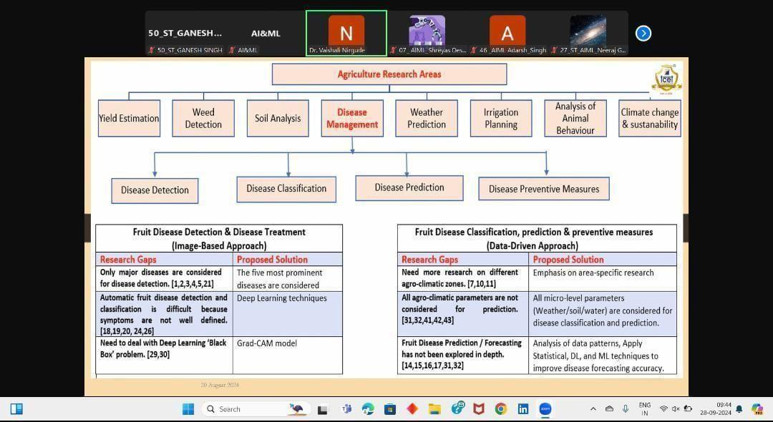

Feedback Analysis:

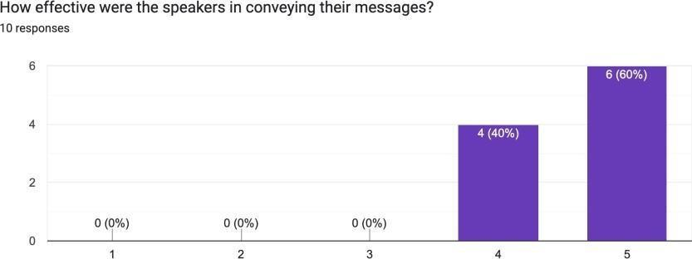

Outcome:

Students were exposed to real-world applications of AI in improving agricultural productivity. The session sparked interest in using AI for sustainable farming practices. Students gained insights into how technology can help tackle some of the biggest challenges in agriculture, such as reducing waste and optimizing resource usage.

PO Attained: PO5, PO7, PO10

Activity 11: Real-Time Rendering in Game Engines and ML.
Date: 29 September 2024
Time: 6:00 PM to 8:00 PM
Speaker: Mr. Utkarsh Kulkarni, MSc in CS at Syracuse University, New York; Data Analyst and AI Engineer

Participants: BT students

Objectives:
  - To explore the integration of AI with real-time rendering techniques in game development.
  - To demonstrate how machine learning can enhance rendering performance and game design.
  - To introduce students to procedural content generation and adaptive gaming techniques.
  - To encourage students to experiment with AI tools and game engines like Unity and Unreal Engine.

Description:
This session focused on the integration of AI with real-time rendering techniques in game engines like Unity and Unreal Engine. The speaker demonstrated how machine learning can be used to optimize rendering performance, adjust game difficulty, and generate procedural content. The session also covered how AI-driven tools help create more immersive and interactive gaming experiences.

Participation Analysis:

Sr. No. | Class | No. of Students
1 | BT | 39
Total: |  | 39

Feedback Analysis:

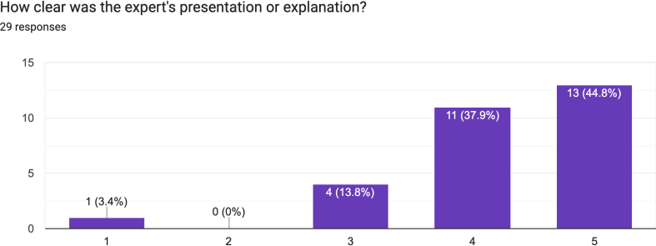

Outcome:

The session provided students with advanced knowledge of AI-driven techniques used in modern game engines. Students learned how machine learning can be used to create adaptive and personalized gaming experiences.

PO Attained: PO5, PO7, PO10

Prepared By:

Mrs. Shilpa Mathur Dr. Shiwani Gupta
Faculty Coordinator Convener
Assistant Professor AI&ML HOD AI&ML

